**Assignment 2 Report**

**Contact Information:**

Name: Ved Ranade

Email ID: [vranade1@binghamton.edu](mailto:vranade1@binghamton.edu)

B-Number: B00715508

Phone: +1-607-232-1815

**Contents:**

1. Purpose of the Assignment
2. Method – Algorithms Used

2.1 Algorithm to calculate X and Y gradient

2.2 Algorithm to obtain histogram of an image in array form

2.3 Algorithm to display histogram

2.4 Algorithm to equalize histogram

2.5 Algorithm to global threshold T

2.6 Algorithm to convert image to binary image

1. Running the programs
2. Results
3. Bug Report
4. **Purpose of the Assignment:**

The purpose of completing this assignment is to understand the following basic visual information processing concepts and to be able to apply them by implementing the concepts in Visual C++ programs:

* Spatial correlation and convolution
* Image smoothing
* Image edge detection
* Laplacian of Gaussian concept
* Unsharp masking
* Sobel operation
* Canny Edge detection

**2. Method - Algorithms Used:**

2.1 Algorithm to calculate X gradient of an image at a particular pixel:

Input: Image, X value of pixel, Y value of pixel

Output: X gradient

Step 1: Let X gradient = p(x-1,y-1) + 2 * p(x,y-1) + p(x+1,y-1) - p(x-1,y+1) + 2 * p(x,y+1) + p(x+1,y+1)

Step 2: Return X gradient

2.2 Algorithm to calculate Y gradient of an image at a particular pixel:

Input: Image, X value of pixel, Y value of pixel

Output: Y gradient

Step 1: Let Y gradient = p(x+1,y+1) + 2 * p(x+1,y) + p(x+1,y-1) - p(x-1,y+1) + 2 * p(x-1,y) +

p(x-1,y-1)

Step 2: Return Y gradient

2.3 Algorithm to perform Unsharp masking:

Input: Initial Image

Output: Final image displayed after Unsharp masking

Step 1: Clone the initial image and set all pixel values of cloned image to zero .

Step 2: Initialize a Gaussian mask:

1 2 1

2 4 2

1 2 1

Step 3: Apply Gaussian mask on initial image using convolution operation and set the result as the final image.

Step 4: Subtract the final image from the initial image and store the result in the final image.

Step 5: Add the final image to the initial image and store the result in the final image.

Step 6: Display the final image

2.4 Algorithm to perform Sobel operation:

Input: Initial Image

Output: Final image displayed after Unsharp masking

Step 1: Clone the initial image and set all pixel values of cloned image to zero .

Step 2: For each pixel in the final image, do:

* Calculate the X gradient
* Calculate the Y gradient
* Calculate the magnitude = absolute value of (X gradient) + absolute value of (Y gradient)
* If magnitude is greater than 255, set it to 255
* If magnitude is less than 0, set it to 0
* Assign the value of the pixel as the magnitude

Step 3: Display the final image

2.5 Algorithm to calculate and apply Laplacian of Gaussian:

Input: Size of mask N, value of sigma, initial image

Output: Value of Laplacian of Gaussian mask, final image

Step 1: For each pixel in the LoG mask m(x,y), do:

* Apply the formula to calculate the LoG:

m(x,y) = (-1/PI*sigma^4)*(1-(x^2+y^2)/2*sigma^2)* e^-(x^2+y^2)/2*sigma^2

Step 2: Print out the LoG mask values

Step 3: Clone the initial image to obtain the final image and set all pixels of the final image to zero

Step 4: Apply the LoG mask to the final image using correlation operation

Step 5: Display the final image

1. **Running the program:**

***OpenCV version 3.3 was used for the execution of this assignment***

Step 1: Unzip the uploaded files to a location

Step 2: Open the Command Prompt in Windows

Step 3: Execute the Solution2.exe executable file using the command prompt and provide an image file full path as a command line argument

Step 4: A menu will be displayed once the program executes. You can now select which question of the assignment to view by entering the corresponding number

1. **Results**

Screenshots for question (2) of the Programming section:

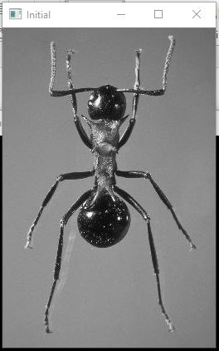 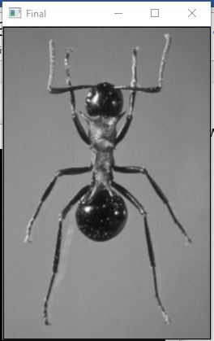

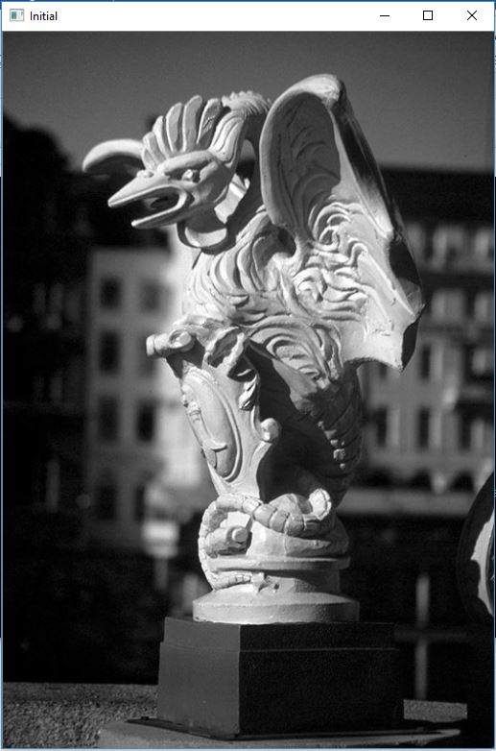 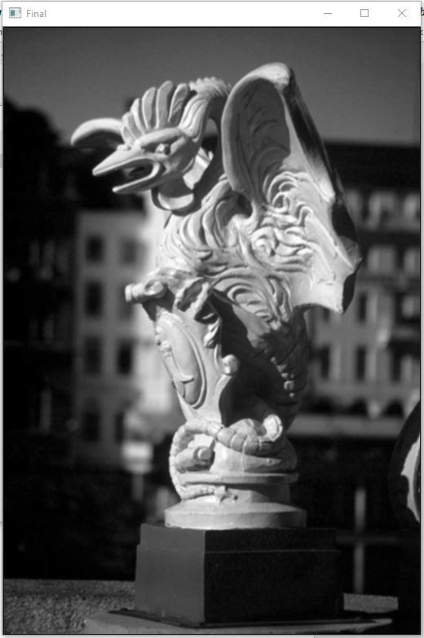

Screenshots for question (3) of the Programming section:

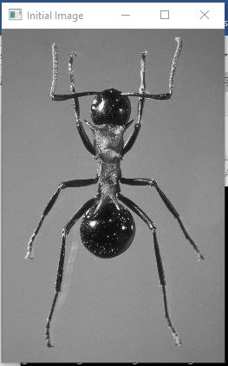 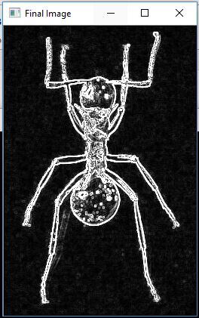

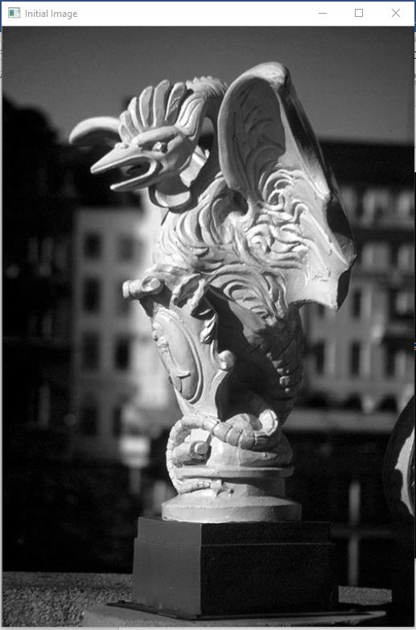 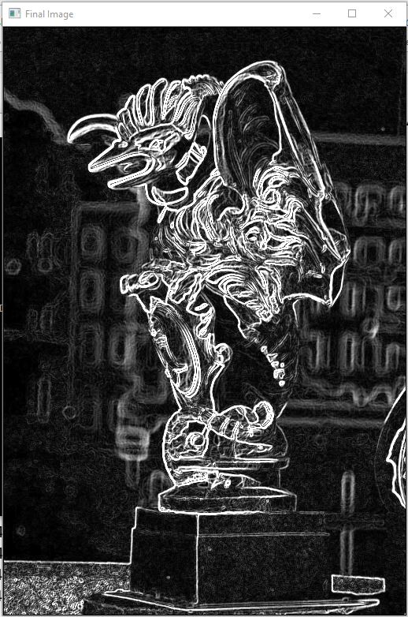

Screenshots for question (4) of the Programming section:

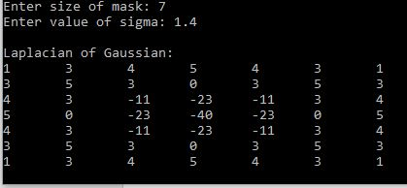

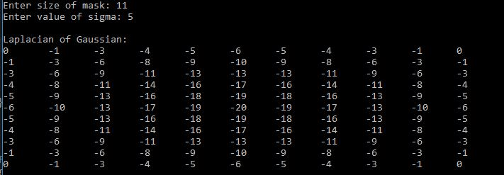

Screenshots for question (5) of the Programming section:

After applying LoG Mask 1: After applying LoG mask 2:

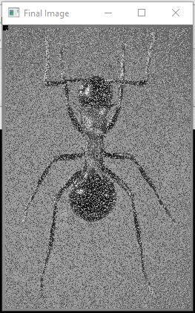 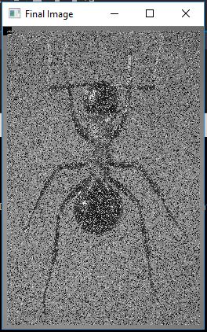

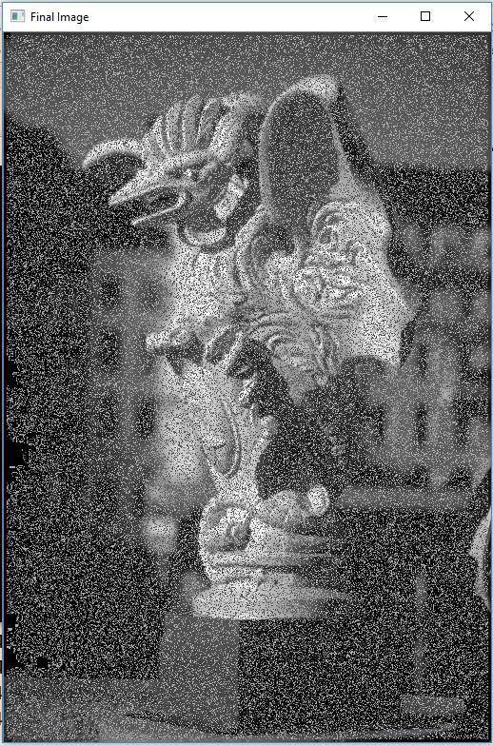 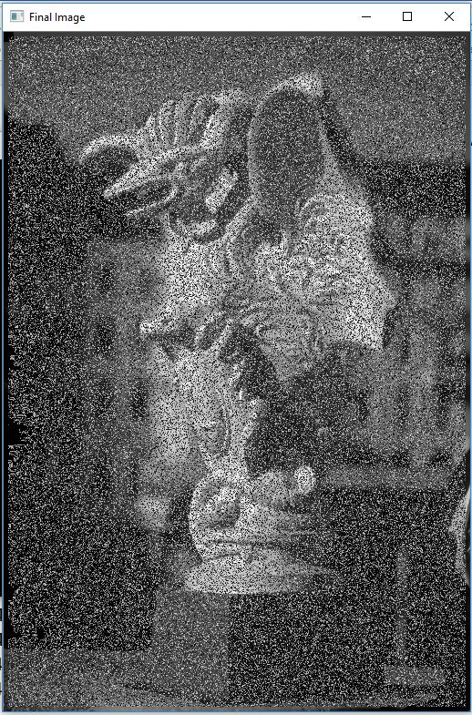

1. **Bug report**

Bug Number 1: On applying the Laplacian of Gaussian mask on the images, the output image does not clearly show the edges in detail.

Parts that are not complete:

Question (6) and question (7) of the programming section.

1. **References**

(1). Digital Image Processing, 3rd Edition, by Rafael C. Gonzalez and Richard E. Woods, Section 3.4

- For understand concept of correlation and convolution and applying it in the programs

(2). Digital Image Processing, 3rd Edition, by Rafael C. Gonzalez and Richard E. Woods, Section 3.5, Section 3.6

- For understanding concepts of median filters, Sobel operation, Unsharp masking, Gaussian blurring, Laplacian of Gaussian and applying these concepts in the programs

(3). [www.homepages.inf.ed.ac.uk/rbf/HIPR2/log.htm](http://www.homepages.inf.ed.ac.uk/rbf/HIPR2/log.htm)

- For further help in understanding how to calculate Laplacian of Gaussian mask

(4). <https://stackoverflow.com/questions/2556958/laplacian-of-gaussian>

- For help in programming the Laplacian of Gaussian mask calculation function

(5). Video upload at: <https://www.youtube.com/watch?v=waNQ-7ckw0I>

- For obtaining clear understanding of image smoothing techniques